Assignment no 3   
Shivam Navnath Giri  
CDAC PGDAI SILCHAR   
FOI

ASSIGNMENT NO 3

FOR EVERY ANSWER MENTION THE NUMBER OF NODES EXPANDED AND THE PATH AS WELL TO REACH A SOLUTION

Q1. Consider the following problem: A Water Jug Problem: You are given two jugs, a 4-gallon one and a 3-gallon one, a pump which has unlimited water which you can use to fill the jug, and the ground on which water may be poured. Neither jug has any measuring markings on it. How can you get exactly 2 gallons of water in the 4-gallon jug? APPLY DFS ALGORITHM TO REACH THE SOLUTION.

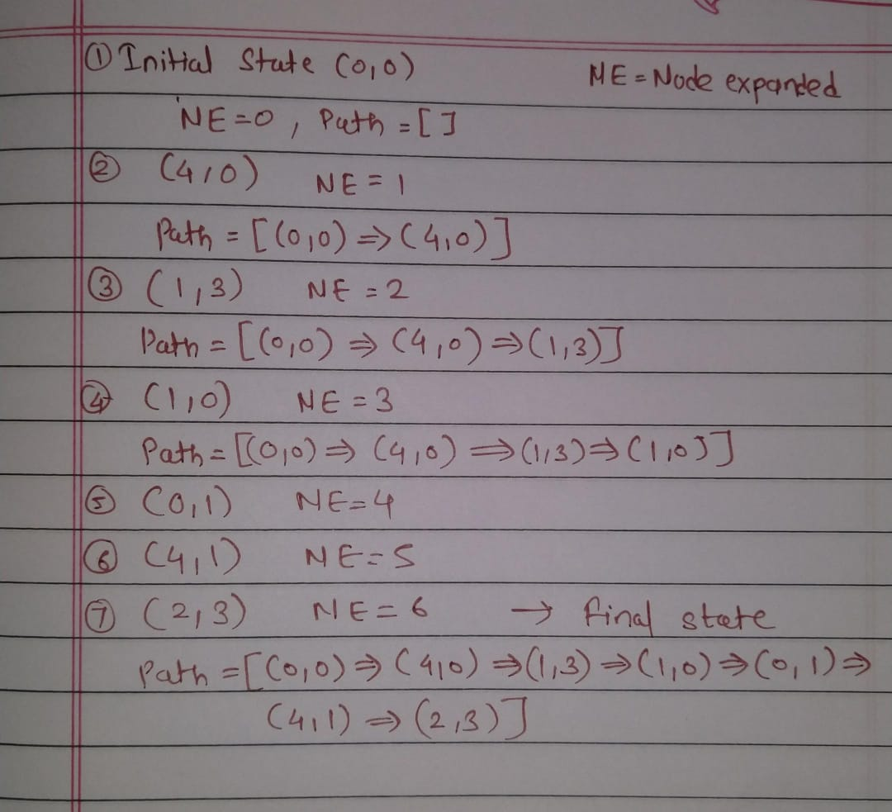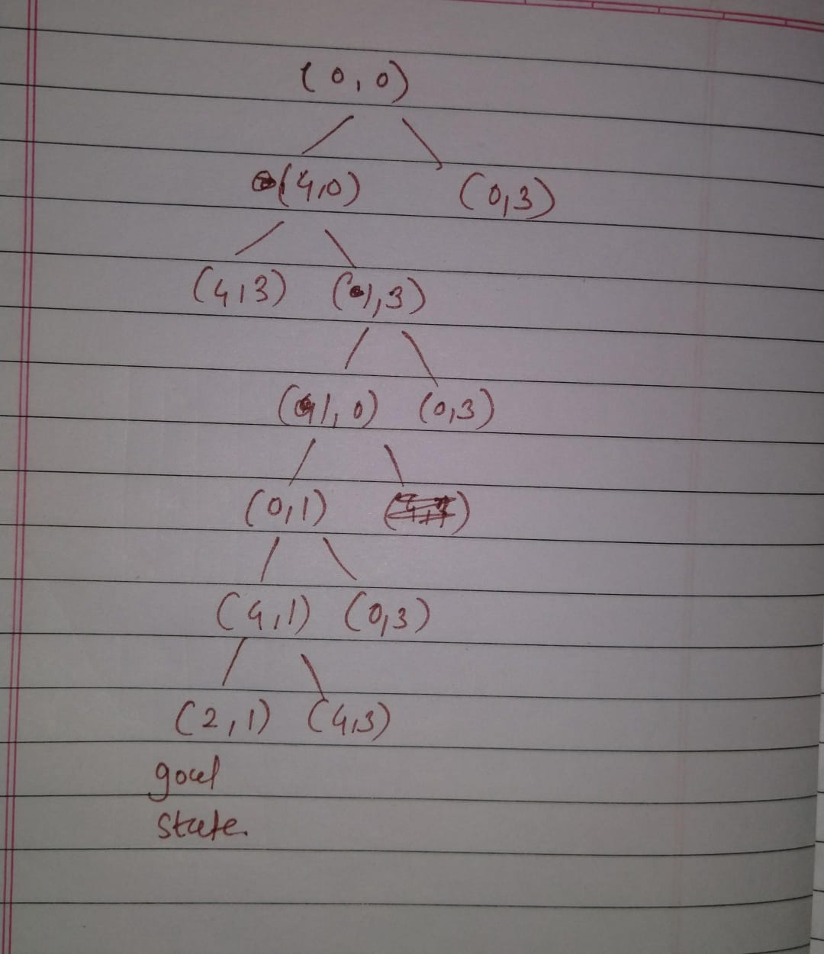

Q2. Given the blocks world indicated in Fig., it is required to get to goal state

from the initial start state. Construct the search tree for: BFS

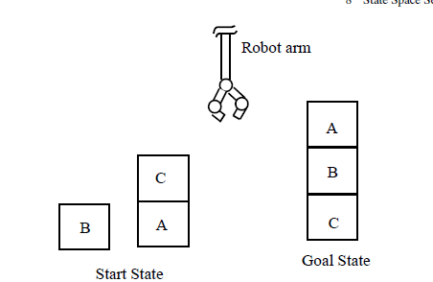

Assume that following rules for moves will be followed by the robot arm for

carrying out this job:

• stack(x, y): stack block x on block y,

• lift(x): lift-up the block x,

• putg(x): put block x on ground,

• unstack(x, y): unstack block x from block y.

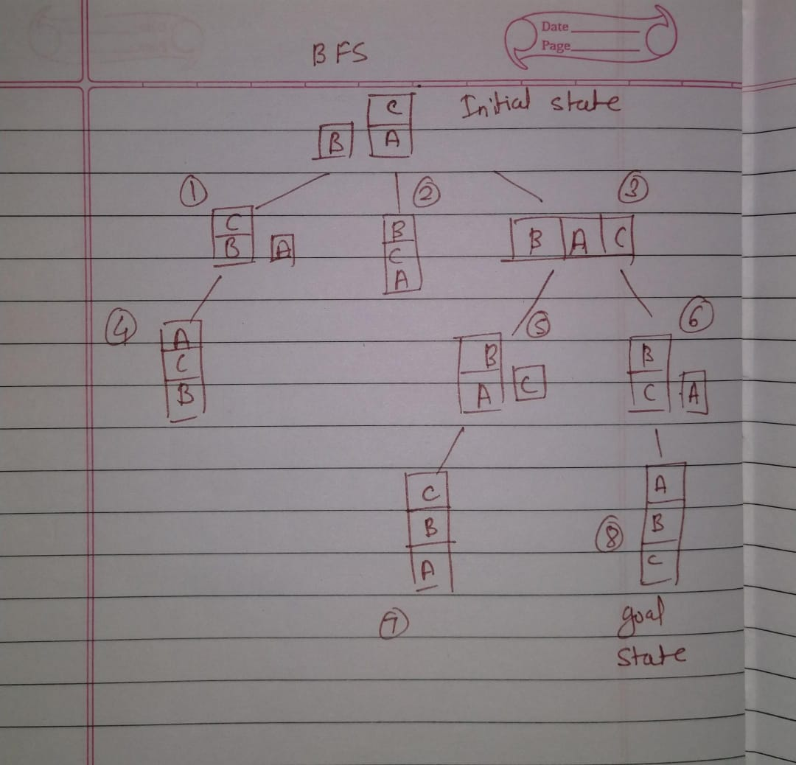

Q3.Solve using ITERATIVE DEEPENING ALGORITHM

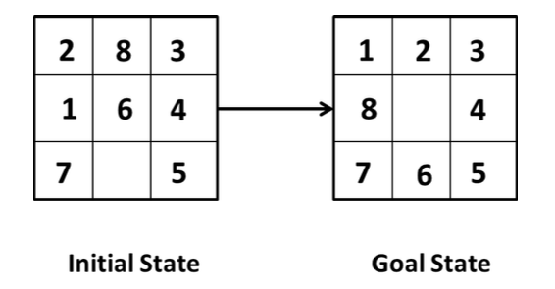

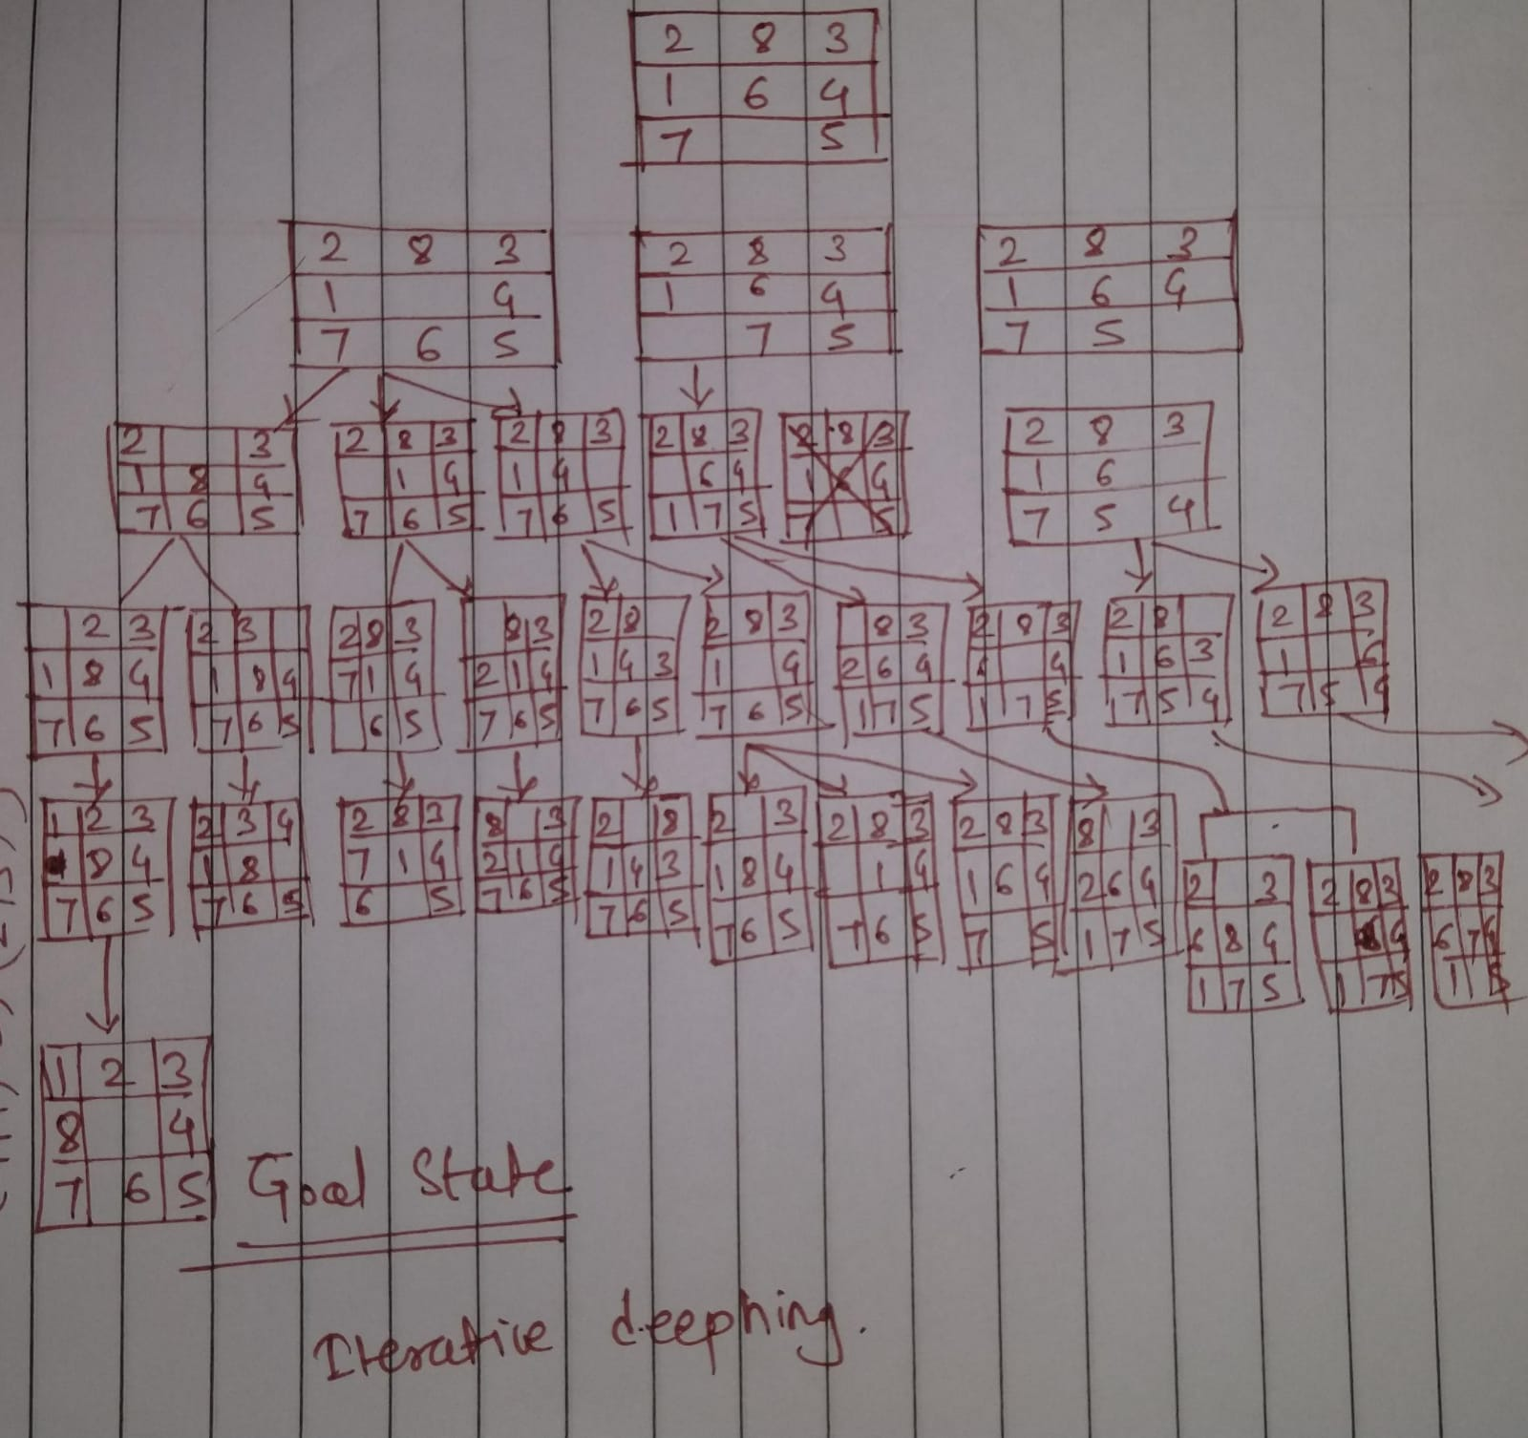

Q4. SOLVE USING BFS

. The missionaries and cannibals problem is usually stated as follows. Three missionaries

and three cannibals are on one side of a river, along with a boat that can hold one or

two people. Find a way to get everyone to the other side without ever leaving a group of missionaries in one place outnumbered by the cannibals in that place.

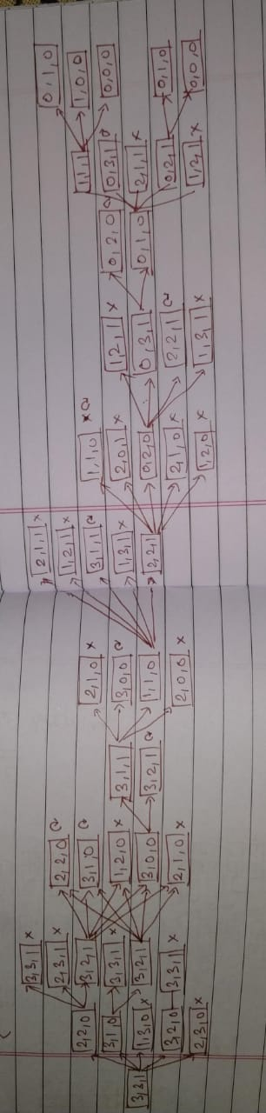

Q5. The map of Romania is given. Start node is Arad and Goal node is  Bucharest. Find the optimal path using uninformed search algorithm.

